JENKINS INSTALLATION in Ubuntu server

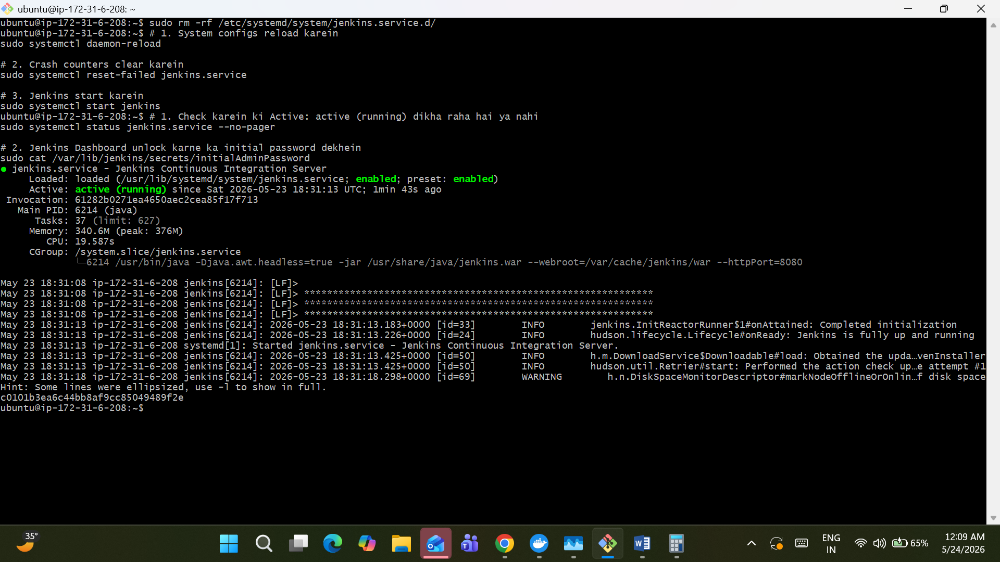

Login into Jenkins and Create and Build the project
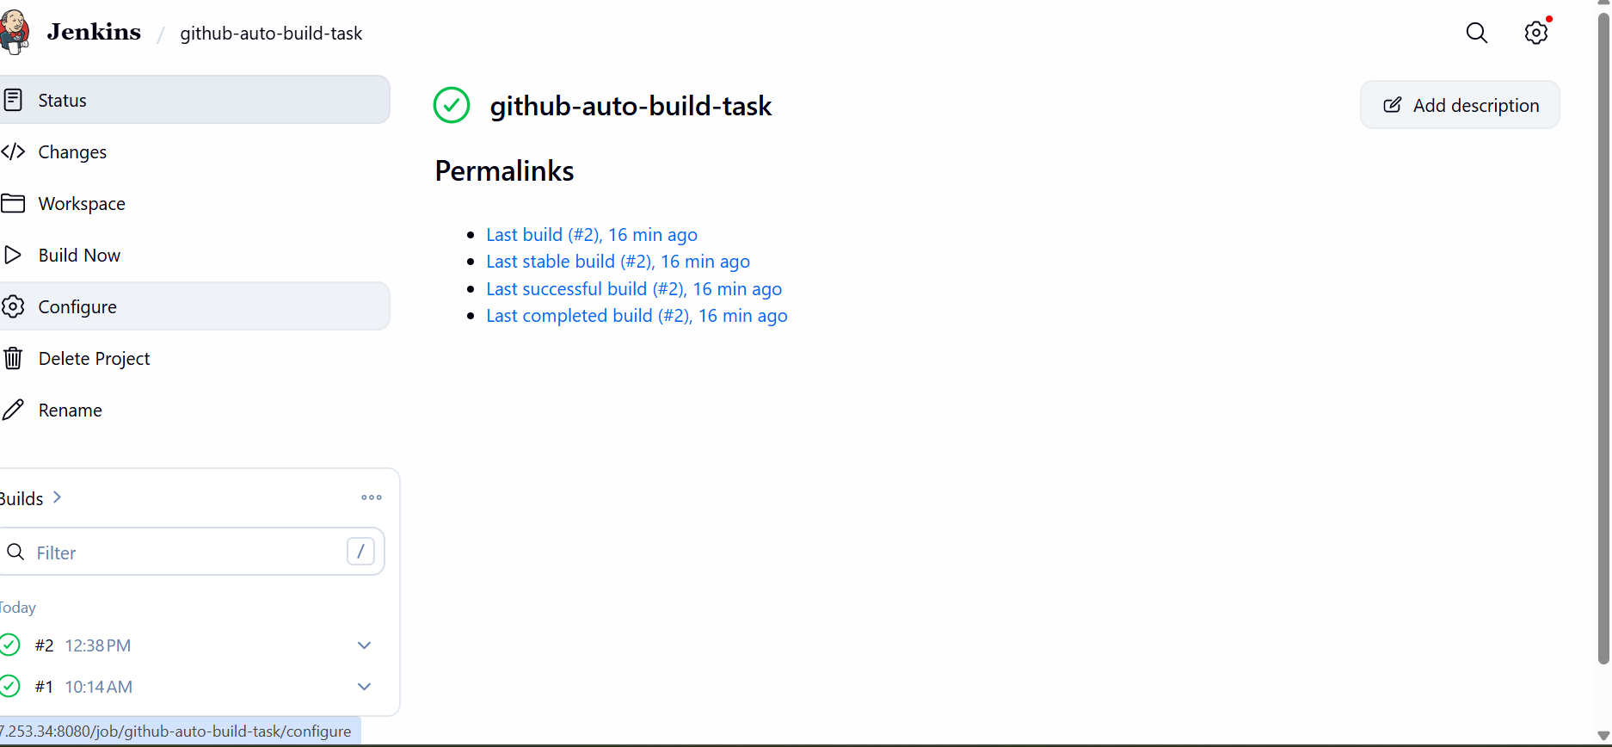

Console output

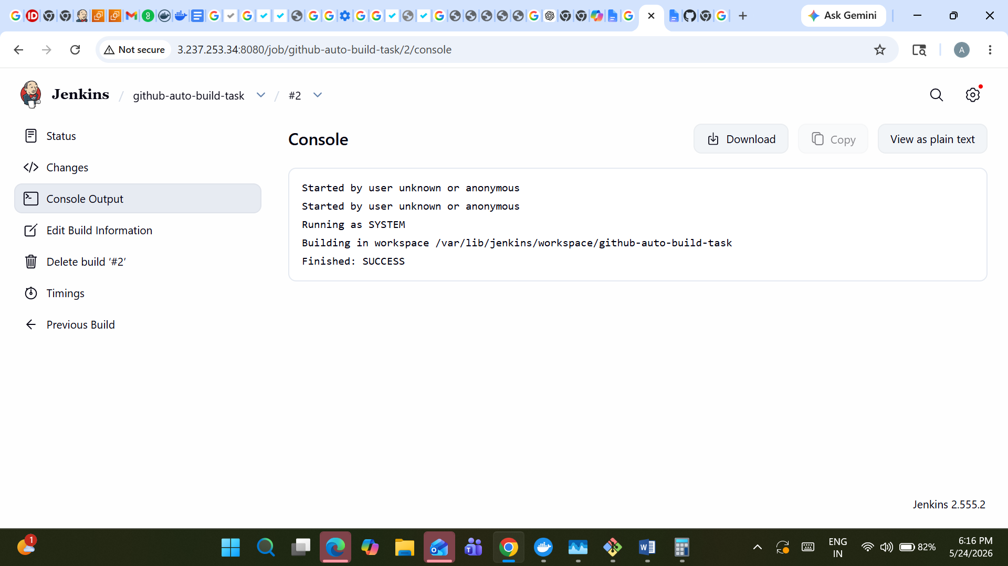

Create Webhook in a GIT hub repository for auto triggred
